FANTASY SPRITE SHOP: A PIXEL ART CUSTOM CHARACTER CREATOR PROGRAM

Kyle Gustafson

**KEY** **WORDS**

Pixel art, digital art, media, customization, character.

**INTRODUCTION**

This paper serves to represent the Fantasy Sprite Shop character creator and to define its purpose. The Fantasy Sprite Shop is a pixel art based character creation program that operates on 6 scrolling sprite sheet options.

**THE PURPOSE**

This program was created as a simple and fun way to play with character design. The program exists only to be relaxing and astatically pleasing. To a lesser extent the program also serves to satisfy and stimulate a desire to fill out every possible combination of a set of objects (in this case 100000 combinations).

**THE ART**

The first step of building this program was to create a simple face shape that did not inherently have a gender. By not having a gender associated with the face the need to create branching gender paths is eliminated and users are allowed to combine “female options” and “male options” on the same character. In the creation of the face shape the first skin tone was also created. the next piece created was the body; the pink option was the first one created simply because, when doing non pixel digital art, I do my sketch work in vibrant pink or lime green as they pop of most any background. However, in doing pixel art base sketch work is less necessary as the limited grid does not allow for much clean up in the line work, thus the first body stayed pink. As arguably the most important feature of the face the eye was created next. The eye is the only facial option that the user can choose from that does not have an empty/bald option. The eye is also the key feature in positioning all other features of the face making it crucial to create first. The first mouth was a simple bar and was made to be a sort of measuring

stick for the other mouths. though not created I order the bonus items were all made while thinking about the bald head. The only bonus item that was made before the other features was the line war paint, which was designed not as an option but as a set of lines to keep the eye all in the same consistent place. before the hair was made all ten options were made for each other button. The skin and hair were bout made in the same way buy selecting the layer they were on, copying it nine time, changing the color with hue, saturation, and recoloring tools, moving the layers even increments apart and then compressing each layer into a single skin or body layer. The other features were done similarly however instead of adjusting colors each new option had to be completely redrawn within a guide box. The hair was done last after the after tuning off all the options but the skin. Again, this was done so that the existing visuals did not influence my creative decisions. The hair was the only layer that was no duplicated and compressed. Background and button choices had to be made very carefully as not to influence the user astatically, this is why greys and a very light gradient was chosen.

There are 600 individual pieces of sprite work in this project (not including the buttons and backgrounds). The various options in this work do not inherently come in standard sets. This means that if one were to go through and click each button a single time before going back to press a button again they would not come across a series of part that were meant to go together in that specific way. This is not to say that there are not “sets” as many pieces were designed with other pieces in mind but the combinations are not presentenced in a straight forward manner. This is done, not to be difficult or to force the user to search for sets, but to encourage he user to think and experiment, as well as to discourage habitual pairing from forming.

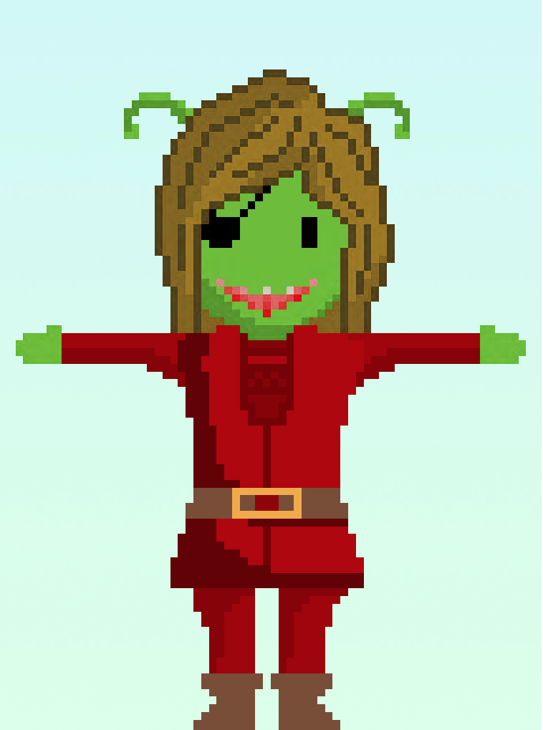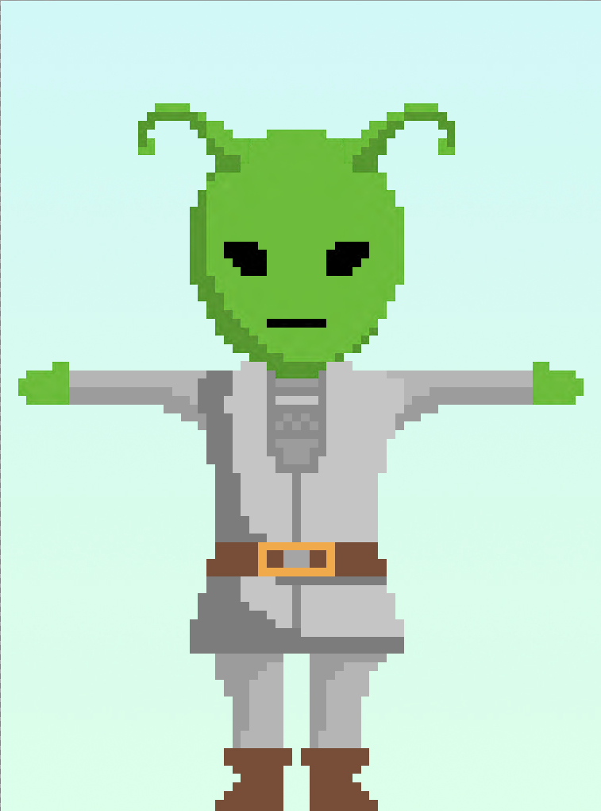

set 7 alien set

**THE CODE**

The code for this project was very simple. It was basically a matter of adding and preloading each image, assigning variables to each image, and creating a button pressed function that cycles each associated option set when pressed. The canvas size was set to be the size of the button image plus the size of a single frame of the body to eliminate the need for a more complicated image function

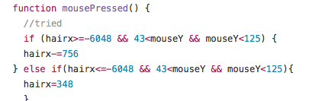

the code for the hair button

**THE WHY**

As for why the program was built, aside from what was mentioned above, I honestly just wanted to play with pixel sprites. The character creator aspect came as an afterthought as a way to implement sprite work into the assignment. Also I enjoyed doing the sprite cycling in previous works so the opportunity to do so again was an extra appealing aspect. On top of that I, and many others, very much enjoy the character creation aspect of some games and am willing to dedicate massively disproportionate amounts of time simply to character creation.

